Arkansas Re-entry Awareness
“It is the policy of the State of Arkansas to encourage and contribute to the rehabilitation of criminal offenders and to assist them in the assumption of the responsibilities of citizenship. The public is best protected when offenders are given the opportunity to secure employment or to engage in a meaningful trade, occupation, or profession.” Ark. Code Ann. § 17-1-103(a).
Legal Aid of Arkansas once again participated in Arkansas Re-entry Awareness Week by hosting events in Fayetteville, Mountain Home, Berryville, Mountain View, Searcy, Jonesboro, Fort Smith, Clarksville, Mena, Conway, Little Rock, Forrest City, West Memphis, Malvern, Pine Bluff, Stuttgart, Monticello, El Dorado, Camden, Magnolia, Texarkana, Batesville, Paragould, Rogers, Harrison, Russellville, Hot Springs, Newport, Osceola, Blytheville, Arkadelphia, and North Little Rock. For more information on these events go to http://www.dcc.arkansas.gov/reentry-awareness-week.

Legal Aid attended the kickoff Prayer Breakfast on Monday, April 23, at 7:00am at the Washington County Sherriff’s Office, featuring Arkansas Community Corrections Deputy Director Kevin Murphy as the guest speaker at this breakfast. Legal Aid was also at the Northwest Community Corrections Center on Wednesday, April 25, at 9:00am to speak with the residents about sealing their records and their housing and employment rights.
The Department of Justice sponsors National Re-entry Week and encourages events designed to improve re-entry outcomes and emphasize the importance of successful re-entry. Some events in Arkansas are listed if you click on the re-entry tab for Arkansas Community Corrections. Visit http://www.dcc.arkansas.gov/reentry to find more events.
“Too often in the nonprofit world, organizations create silos. They are working so hard to meet the needs of the clients. This leads them to recreate existing services. By doing so they raise their budget and find themselves providing services that are outside of their skill set and passion. This approach is unsustainable and leads to short term services. The NWA Re-entry Coalition provides a space for organizations that cross a number of service provider sectors a place to come together to get inspired, educated, and learn to collaborate. By doing so they can best serve their client’s needs,” said Nick Robbins, Returning Home Executive Director. NWA Re-entry Coalition meets at the Returning Home Center, 703 N. Thompson St, Springdale on the second Thursday of each month from 2:00-3:30pm.
According to the United States Department of Justice Archives (March 2016), each year across the nation, more than 600,000 individuals return to our neighborhoods after serving time in federal and state prisons. Another 11.4 million individuals cycle through local jails.
In 2012, the federal government put pressure on all employers to consider applicants with criminal records when a federal board, the Equal Employment Opportunity Commission (EEOC) warned employers that excluding applicants because of their records may violate anti-discrimination laws. Employers can consider a conviction, but must consider how minor the conviction is, how long ago it happened, and the nature of the job you are applying for. Employers are encouraged to treat each case individually.
An employer’s attitude presents more of a barrier to hiring people with a criminal history than the law does. Many employers are fearful that applicants with criminal records will be poor workers or will commit crimes. However, research shows that people with criminal records are indeed reliable workers. A Northwestern Law School study of tens of thousands of hires into low-skill white collar jobs found that those with records stayed at their jobs longer and were no more likely to get fired than hires without records. “This evidence taken together suggests that employees with a criminal background are in fact a better pool for employers,” the study said (http://www.sole-jole.org/17537.pdf).
Re-entry has been a major focus of legislatures in recent years as a bipartisan issue. In the past few weeks, congressional leaders have supported three acts aimed at improving re-entry and reducing recidivism: the Second Chance Act (SCA), the Mentally Ill Offender Treatment and Crime Reduction Act (MIOTCRA), and the Justice Reinvestment Initiative (JRI). The SCA provides grants for important services like employment training, substance abuse treatment, education, housing, family programming, mentoring, victims support, and many others. Over 800 SCA grants have been awarded in 49 different states. The MIOTCRA will continue to be funded to improve access to treatment for people with mental illnesses in the criminal justice system. The JRI will continue to be funded. Its purpose is to help reduce criminal justice spending while reinvesting the savings towards improving community supervision and treatment programs.
Another recent development is the creation of a uniform risk and needs assessment. Risk and needs assessments are used routinely in correctional systems to estimate a person’s likelihood of recidivism and provide direction concerning appropriate correctional interventions. The National Reentry Resource Center (NRRC) has worked with doctors to establish a standardized system for assessing and classifying the risk of recidivism into five specific levels. More information on these levels can be found at https://csgjusticecenter.org/nrrc/posts/white-paper-introduces-a-common-language-to-communicate-about-criminogenic-risk/.
Employers often feel more comfortable hiring felons who have been vetted by a community organization or workforce intermediary. Here are some community resources in Arkansas that assist in reentry.
Arkansas Reentry Programs and Assistance
Arkansas Community Corrections – A list of resources and other beneficial links for ex-offenders set up by Arkansas.gov. http://www.dcc.arkansas.gov/reentry
InnerChange Freedom Initiative – A faith-based re-entry program based on the teachings of Jesus Christ. This program is aimed at reducing the rate of recidivism in Arkansas.
Little Rock Re-Entry Services – Re-entry program to help ex-offenders in the city of Little Rock. In addition to the program itself, there is also a list of re-entry programs in the city of Little Rock for ex-offenders.
Goodwill Industries of Arkansas – Goodwill’s Transitional Employment Opportunity program helps people returning from incarceration. This program offers job services, both training and placement.
CARE Coalition – This is the Central Arkansas ReEntry Coalition, or CARE. Their mission is to “empower returning citizens for a productive life through advocacy, education, and collaboration.” It works with many different groups to help ex-offenders re-enter society.
Pathway to Freedom, Inc. – A Christian faith-based program that offers many services such as education, that takes a three phase approach. The first phase works to educate, the second tests the individuals in real life settings, and the third is local support for ex-offenders after they are released.
Returning Home – A jail and prison ministry in Northwest Arkansas dedicated to improving the quality of life by helping break the cycle of imprisonment and helping clients overcome barriers to successful re-entry. A part of the ministry is the Legal Needs Assessment Project. A licensed attorney and/or supervised law student conduct interviews by appointment. Call (479) 287-5870 for more information. Visit www.returninghomenwa.com for more information about this program.
These Arkansas Department of Community Correction graphics show how successful re-entry affects all counties:

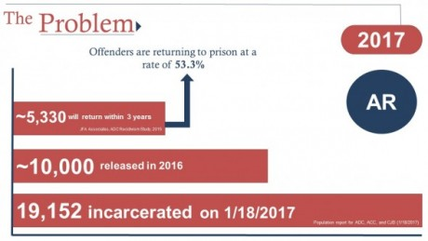
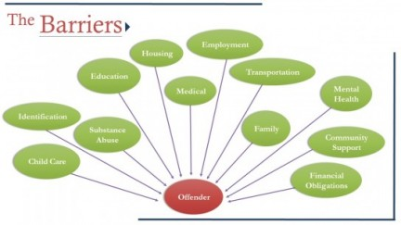
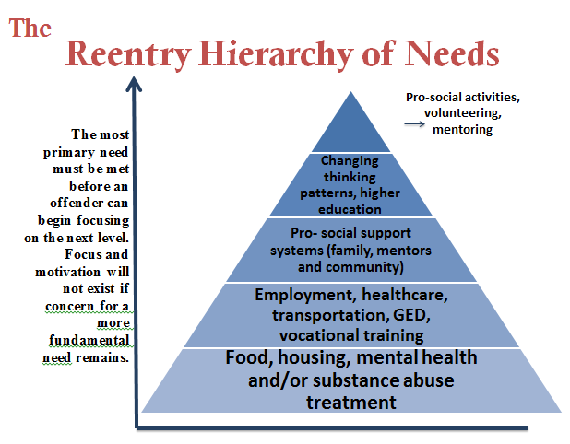
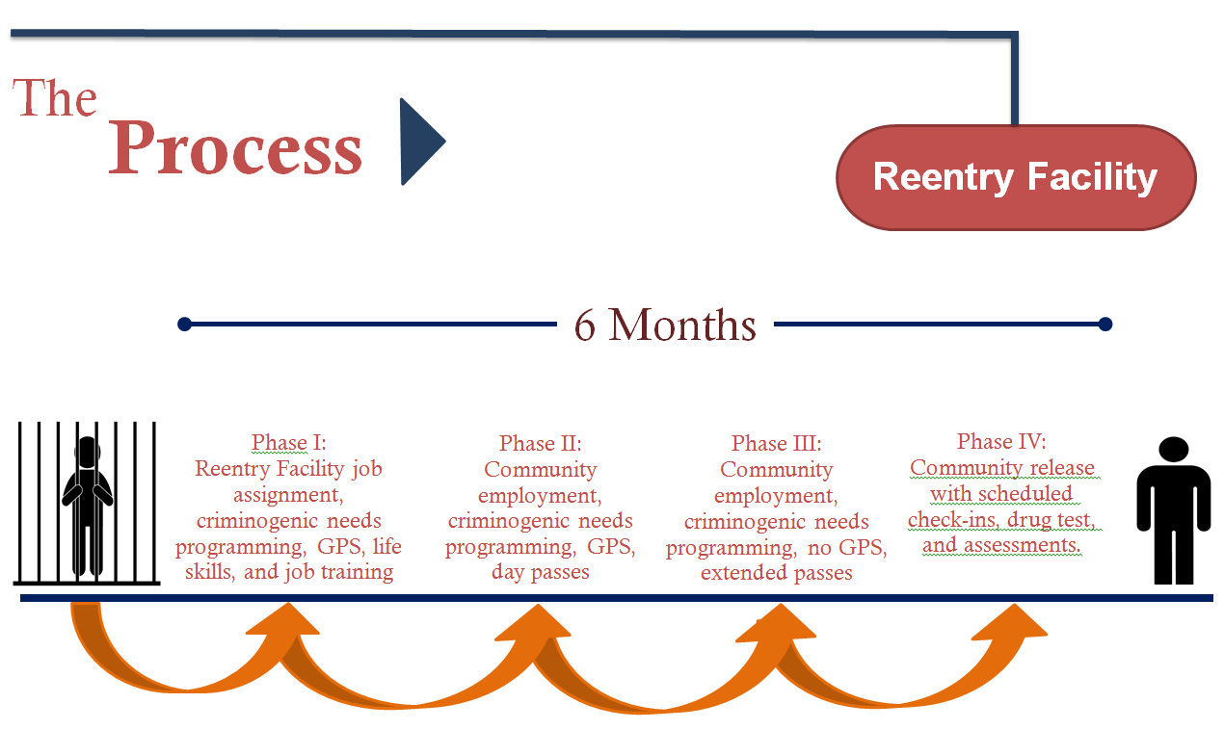
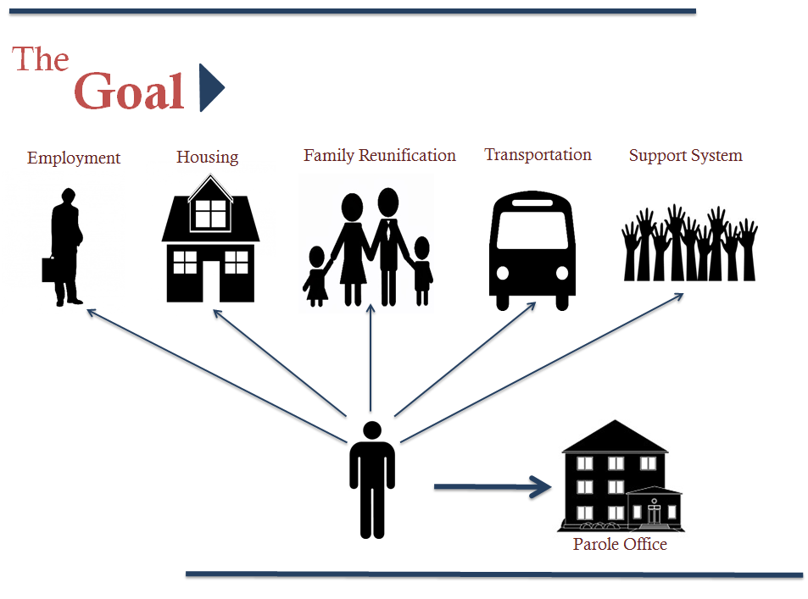
Source: Arkansas Community Correction

